Safe Methods for Animal Injections
Before administering any material to a laboratory animal, it is important to make sure the animal is properly and comfortably restrained. This will ensure that movements will not lead to misplaced injections or accidental injury to the animal or the handler. There are a variety of restraint methods and devices to use that will allow you to safely carry out a procedure using a needle or cannula.

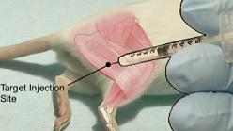 |  |  | Intramuscular Injections (IM)  Regardless of the method used for intramuscular injections, it must be noted that the sciatic nerve runs along the length of the femur. It is very important to avoid injuring this nerve. This is best accomplished by pointing the needle, caudally rather than cranially, into the caudal thigh muscles. It is imperative that the mouse be properly restrained. If the mouse is allowed to kick or struggle, this could cause injury to the muscles or the nerve. It is best to swab the area with 70% ethanol before placing the needle and to aspirate to look for blood before injecting.
IM Method #1  Restrain the mouse by the scruff method. Secure the rear foot nearest to you beneath your little finger and lower thumb. Swab the area to be injected with 70% ethanol. Insert the needle, bevel up, into the caudal thigh at a 45° angle. Aspirate to ensure that you have not entered a blood vessel. If no blood is seen, slowly inject the material. |  |  |  | 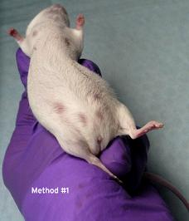 |  |  | 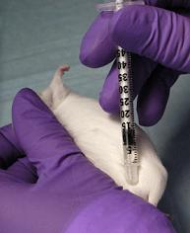
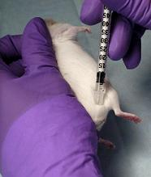 |  | IM Method #2  Restrain the mouse by the scruff method. Swab the area to be injected with 70% ethanol. Insert the needle into the caudal thigh, bevel up. Aspirate and inject. Since the foot has not been secured, make sure the mouse does not kick.
IM Method #3  A technique using two people can also be used for IM injections. One person restrains the mouse by the scruff method with one hand and steadies the leg to be injected with the other. The second person identifies the caudal thigh muscles, swabs the area with 70% ethanol, aspirates and injects the material. |  |  |  |  | 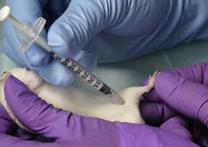
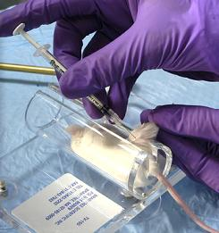 |  | IM Method #4  A tail first restrainer can also be used for IM injections. Gently pull the foot of the leg to be injected through the restrainer and locate the caudal thigh muscle. Hold the foot firmly, swab the site with 70% ethanol, aspirate and inject the material with the needle bevel up.
Subcutaneous Injections  Restrain the mouse by the scruff method. Use your thumb and forefinger to make a tent of skin over the scruff. Prep the area with 70% ethanol. Insert the needle, bevel up, at the base of the tent. The needle should be inserted parallel to the skin and should be directed toward the posterior of the animal. Aspirate to ensure proper placement and inject the material. |  |  |  |  |  | 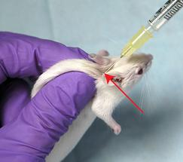
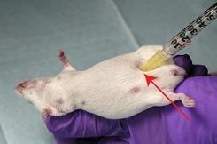 | Intraperitoneal Injections  Restrain the mouse by the scruff method. Expose the ventral side of the animal, tilting the head down at a slight angle. Prep the site with 70% ethanol. The sterile needle should be placed, bevel up, in the lower right or left quadrant of the animal’s abdomen. Insert the needle at a 30° angle. Aspirate to ensure proper placement and inject the material.
Intravenous Injections  Warm the mouse under a heat lamp or other heating device, being sure not to OVERHEAT the animal. The temperature should not exceed 85 - 90° Fahrenheit at the level of the animal. Remove the mouse from the heat source immediately should any change in respiration rate or excessive salivation be observed. Other heating devices, such as disposable hand warmers, may be used in lieu of a heat lamp. Place the animal in a restraint device and stabilize the tail between the thumb and forefinger of the hand that will not be manipulating the syringe. Prep the tail with 70% ethanol. Attempt the injection starting at the middle or slightly distal part of the tail. With the tail under tension, insert the needle, bevel up, approximately parallel to the vein and insert the needle at least 3 mm into the vein. DO NOT ASPIRATE, as it will cause the vein to collapse. Inject the material in a slow, fluid motion. You should be able to see the vein blanch if the needle is properly positioned. If any swelling at the injection site or resistance to injection occurs, remove the needle and reinsert it slightly above the initial injection site. |  |  |  |  |  |  | 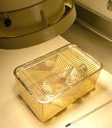
 |  |  |  |  |  |  | 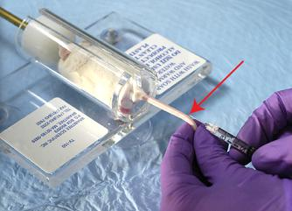
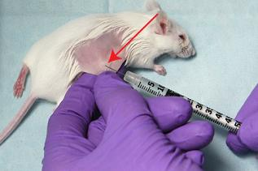 | Intradermal Injections  In order to perform intradermal injections, the mouse should be anesthetized. Shave or pluck an injection site on the back of the animal to remove the hair. Swab the site with 70% ethanol. Insert the needle into the skin, bevel up, holding the needle nearly parallel to the plane of the skin. Do not aspirate. Inject the material. A properly performed intradermal injection will result in a small, round skin welt.
Oral Gavage  Gavaging is used to dose an animal with a specified volume of material directly into its stomach. Only a specialized, commercially available gavage needle should be used for this procedure. Fill the syringe with the appropriate volume of material and attach the needle. Restrain the animal by the scruff. Place the tip or ball of the needle into the animal’s mouth. Slide the tip gently past the back of the tongue. The needle should slide easily down the esophagus, if properly placed. DO NOT FORCE!!! If any resistance is met, remove the needle and reinsert. Do not aspirate. Once the needle is properly placed, administer the material. |  |  |  |  |  |  | 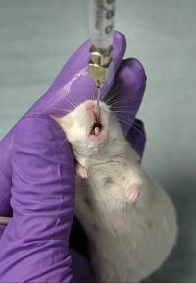
Remember
- Select the appropriate restraint method, injection route, volume, site and needle gauge for your purposes.
- Prep the site with 70% ethanol.
- Always inject with the needle bevel up.
- When warming animals, DO NOT OVERHEAT.
- All injection procedures must be described in your Animal Study Proposal.
- Consult your veterinarian for further information concerning injections.

WSU Office of Environmental Health & Safety
www.oehs.wayne.edu SOURCE: http://www.theodora.com/rodent_laboratory/injections.html

