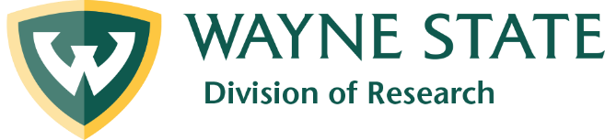

Update on Completed Research Awards
PI name

PI title

PI department and college/school
Title of awarded project

Funding agency

PI’s current residence (city, state)
Other universities involved in project

Co-PI’s and other investigators involved in project (include their department and college/school)
Has results from this research project been published, and if so where and when?
If results have not yet been published, do you plan to publish and when?
Are there any significant results that are or will be newsworthy?
Please give a layman’s description of this project and results, if published. (Attach additional page if necessary.)
Please email completed forms to Julie O’Connor, director of Research Communications, at julie.oconnor@wayne.edu.

